Task and Audience Analysis Exercise
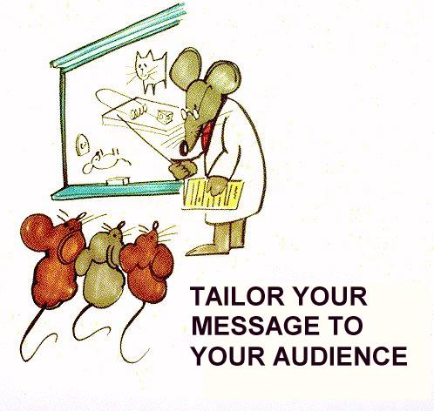

Exercise 1: What to include? What to leave out?
Table 1 contains a collection of details about a research project on a work-from-home (WFH) model for your company. Imagine that you're writing documents for each of the 5 following audiences:
A. Your boss
B. Human resources officers
C. The general public
D. Politicians
E. Students
Consider the type of information about the WFH model that each audience might ask you. As you go down the list, write in the blank spaces in front of each detail the letter that corresponds to the audiences that you think would find this detail most relevant. Consider what kind of document might contain that information for that audience.
Table 1. Details About Your Research Project on the Work-from-Home (WFH) Model
The dollar cost of shifting to a WFH model
A literature review of previous research on WFH.
Descriptions of digital communication tools.
Some basic strategies for conducting online meetings.
How much the entire project costs.
A log of all your research during the whole project.
A list of everyone who worked on the project.
Minimum specifications for equipment to be used in WFH.
A new result showing a connection between WFH and productivity.
A new result showing the mental health impact of WFH.
New insights into the challenges in implementing WFH.
Procedures you used to avoid statistical biases in your data.
Your plans for further assessments.
Your recommendations for future research.

Exercise 2: Compare audience needs

What differences in purpose, content, and format would you need to consider in the following examples:

1) A report on Internet Privacy Issues for a new internet user
for an e-commerce website developer

2) Information on Lyme Disease for camping enthusiasts
for a family practice physician
for public health department

3) Food born diseases for a restaurant worker
for a health inspector training manual

4) Proposal for a new bus shelter design Mayor’s office
Contractor
Newspaper reporter

Use the schematic in Table 2 to determine what kind of document with what kind of content would be appropriate for the various audiences above.

Table 2. Audience Analysis Schematic
4 categories of audiences | Examples/roles | Kind of information required:
Laypeople | General public  Non-Specialists  General “users”
Executives | Decision Makers  (manage resources and people)
Experts | Advisors  (use their expertise to help decision makers)
Human resources | Implementers

Exercise 3: Task and Audience Analysis
Compare these two tasks in terms of intended audience and purpose.

 | End of term Course Evaluation | a Ratemyprofessor.com entry
Purpose
Audience
Author
What details would you include? What info would your audience expect?

